Supplementary material

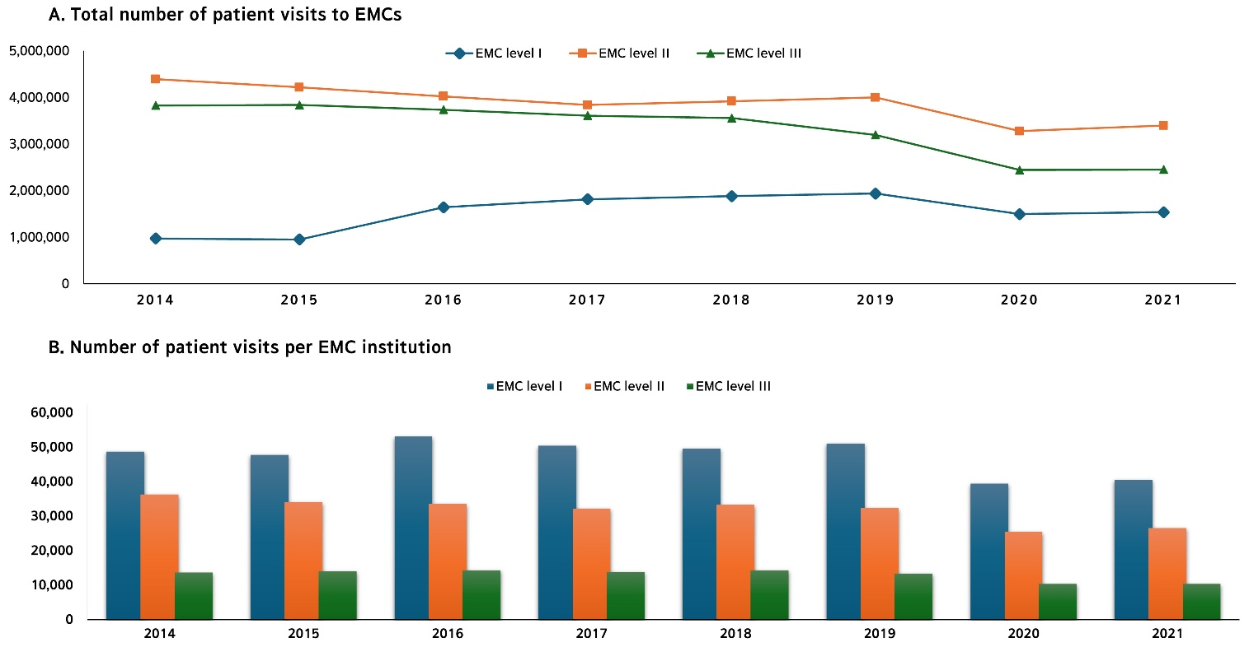
Supplementary Fig. 1. Annual trends in patient visits per 1000 population by emergency medical center level and institution, 2014–2021. (A) Total number of patients visits to EMCs. Level II EMCs consistently recorded the highest number of patient visits nationwide (p < 0.01, 95% CI: −0.98 to −0.52). Although level I EMCs had the lowest number of visits, they exhibited an increasing trend over time (p = 0.13, 95% CI: −0.21 to 0.91). In 2020, patient visits declined across all EMC levels but showed a slight rebound in 2021. (B) Number of patient visits per EMC institution. The average number of patient visits per institution was highest in level I EMCs and lowest in level III EMCs. From 2014 to 2019, the average number of visits per level I EMC remained stable, ranging from 48,700 to 51,100 visits, but declined to 39,400 in 2020, followed by a slight increase to 40,600 in 2021. EMC: Emergency Medical Centers.

Supplementary Fig. 2. Annual proportion of computed tomography (CT) scans per patient visit by gender at Emergency Medical Centers (EMCs), 2014–2021. From 2014 to 2021, the proportion of male patients visiting EMCs nationwide declined from 52.19% to 50.22%, narrowing the gender gap from 4.38% in 2014 to 0.43% in 2021 (p < 0.01, 95% CI: 0.59–0.98 for trend).

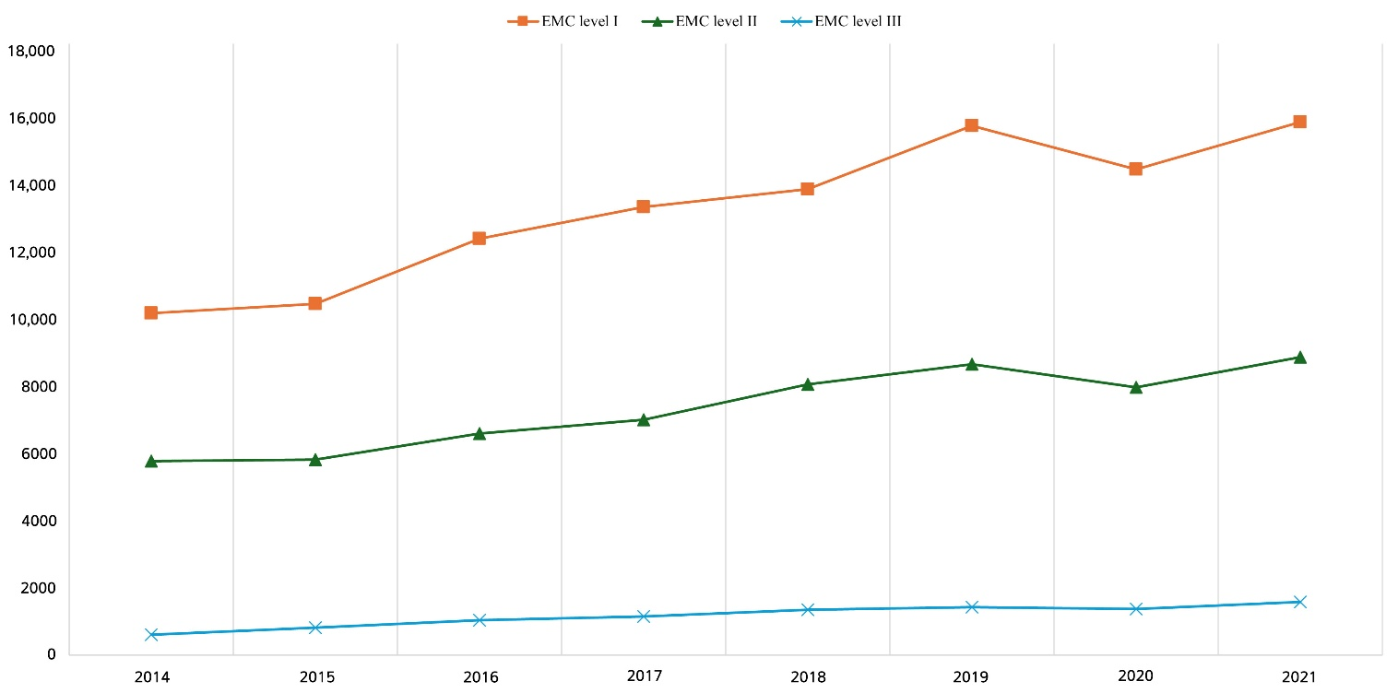
Supplementary Fig. 3. Annual number of CT scans per EMC institution. EMC: Emergency Medical Centers.

Supplementary Table 1. Annual CT utilization proportion by age at Emergency Medical Centers, 2014–2021.
Year |  | 2014 | 2015 | 2016 | 2017 | 2018 | 2019 | 2020 | 2021 | p-value | 95% CI
Age group (%)
 | ≤9 | 2.78 | 2.82 | 3.02 | 3.18 | 3.28 | 3.88 | 5.80 | 6.48 | 0.003 | 0.48 to 0.98
 | 10–19 | 9.01 | 9.22 | 10.74 | 11.61 | 12.06 | 13.41 | 16.26 | 17.79 | <0.001 | 0.84 to 0.99
 | 20–29 | 9.34 | 10.06 | 12.05 | 12.89 | 13.85 | 15.31 | 17.50 | 19.21 | <0.001 | 0.95 to 0.99
 | 30–39 | 9.64 | 10.46 | 12.52 | 13.65 | 14.94 | 16.99 | 19.30 | 20.84 | <0.001 | 0.97 to 0.99
 | 40–49 | 12.24 | 13.09 | 15.55 | 16.97 | 18.35 | 20.82 | 23.57 | 24.98 | <0.001 | 0.97 to 0.99
 | 50–59 | 14.24 | 15.29 | 18.32 | 19.72 | 21.38 | 24.14 | 27.69 | 29.42 | <0.001 | 0.96 to 0.99
 | 60–69 | 17.00 | 18.30 | 22.21 | 23.90 | 26.05 | 29.09 | 33.49 | 35.80 | <0.001 | 0.96 to 0.99
 | 70–79 | 21.47 | 23.71 | 28.47 | 31.33 | 34.37 | 37.88 | 43.59 | 47.07 | <0.001 | 0.97 to 0.99
 | ≥80 | 22.04 | 24.96 | 30.56 | 34.64 | 39.34 | 44.22 | 52.12 | 57.38 | <0.001 | 0.97 to 0.99
CT: computed tomography; CI: confidence interval.

Supplementary Table 2. Trends in the top 10 annual presenting symptoms for CT scans per 1000 population at Emergency Medical Centers, 2014–2021.
2014  (%) | 2015  (%) | 2016  (%) | 2017  (%) | 2018  (%) | 2019  (%) | 2020  (%) | 2021  (%)
Non-contrast Brain CT
Headache (18.4) | Headache (18.73) | Headache (19.02) | Headache (18.63) | Headache (18.44) | Headache (18.64) | Headache (16.45) | Headache (17.17)
Dizziness (12.26) | Dizziness (12.97) | Dizziness (14.02) | Dizziness (14.66) | Dizziness (15.22) | Dizziness (15.48) | Dizziness (15.10) | Dizziness (16.54)
Syncope (3.29) | Syncope (3.37) | Syncope (3.79) | Syncope (3.95) | Syncope (4.11) | Syncope (4.11) | Syncope (3.91) | Syncope (3.86)
CC trauma (2.81) | Scalp laceration (2.53) | Scalp laceration (2.28) | CC trauma (2.44) | CC trauma (2.59) | CC trauma (3.04) | CC trauma (3.49) | CC trauma (3.40)
Scalp laceration (2.71) | CC trauma (2.31) | CC trauma (2.24) | Scalp laceration (2.25) | Asthenia (2.18) | Asthenia (2.28) | Asthenia (2.53) | Asthenia (2.79)
M/S changes (2.00) | Seizures (2.03) | Seizures (1.92) | Seizures (1.95) | Scalp laceration (2.14) | Scalp laceration (2.17) | Scalp laceration (2.35) | Scalp laceration (2.03)
Contusions (1.89) | M/S changes (1.94) | M/S changes (1.88) | Asthenia (1.92) | Seizures (1.92) | Seizures (1.76) | Seizures (1.88) | Fever (1.92)
Seizures (1.89) | Contusions (1.82) | Asthenia (1.87) | M/S changes (1.77) | M/S changes (1.78) | Fever (1.61) | Fever (1.80) | M/S changes (1.70)
Dysarthria (1.70) | Dysarthria (1.77) | Dysarthria (1.77) | Dysarthria (1.76) | Fever (1.67) | M/S changes (1.55) | M/S changes (1.72) | Dyspnea (1.64)
Disorientation (1.66) | Asthenia (1.75) | Disorientation (1.69) | Disorientation (1.73) | Dysarthria (1.62) | Dysarthria (1,51) | Disorientation (1.58) | Seizures (1.63)
Contrast-enhanced abdominal CT
Abd pain (37.69) | Abd pain (35.77) | Abd pain (36.87) | Abd pain (36.21) | Abd pain (35.69) | Abd pain (35.44) | Abd pain (35.21) | Abd pain (34.06)
Fever (7.38) | Fever (8.42) | Fever (9.11) | Fever (9.77) | Fever (10.38) | Fever (11.18) | Fever (10.83) | Fever (10.39)
RLQ pain (5.10) | RLQ pain (4.87) | RLQ pain (4.53) | RLQ pain (4.13) | Epi pain (4.06) | Epi pain (4.11) | Epi pain (4.33) | Epi pain (4.27)
Epi pain (3.99) | Epi pain (4.21) | Epi pain (3.82) | Epi pain (3.99) | RLQ pain (3.83) | RLQ pain (3.52) | RLQ pain (3.50) | Dyspnea (3.81)
Flank pain (2.06) | Flank pain (2.06) | Rt Flank pain (2.16) | Rt Flank pain (2.23) | Dyspnea (2.54) | Dyspnea (2.64) | Dyspnea (3.07) | RLQ pain (3.64)
Rt Flank pain (2.00) | Rt Flank pain (2.02) | Flank pain (2.00) | Dyspnea (2.14) | Flank pain (2.22) | Flank pain (2.27) | Flank pain (2.47) | Asthenia (2.53)
Low Abd pain (1.76) | Low Abd pain (1.82) | Dyspnea (1.95) | Flank pain (2.04) | Rt Flank pain (2.17) | Rt Flank pain (2.05) | Asthenia (2.18) | Flank pain (2.53)
Vomiting (1.73) | Vomiting (1.80) | Lt Flank pain (1.88) | Lt Flank pain (1.98) | Lt Flank pain (1.97) | Asthenia (1.99) | Rt Flank pain (2.00 | Rt Flank pain (1.94)
Lt Flank pain (1.60) | Dyspnea (1.78) | Asthenia (1.78) | Asthenia (1.78) | Asthenia (1.94) | Lt Flank pain (1.79) | Lt Flank pain (1.70) | Lt Flank pain (1.64)
Dyspnea (1.52) | Lt Flank pain (1.71) | Vomiting (1.70) | Vomiting (1.67) | Vomiting (1.68) | Vomiting (1.65) | Vomiting (1.38) | Low Abd pain (1.31)
Non-contrast Chest CT
Dyspnea (21.63) | Dyspnea (22.57) | Dyspnea (23.78) | Dyspnea (23.81) | Dyspnea (23.44) | Dyspnea (21.77) | Dyspnea (15.99) | Dyspnea (17.10)
Fever (12.88) | Fever (14.54) | Fever (15.94) | Fever (15.92) | Fever (16.54) | Fever (16.98) | Fever (13.56) | Fever (11.38)
Mastodynia (5.26) | Mastodynia (5.01) | Mastodynia (4.56) | Chest wall pain (4.79) | Asthenia (5.04) | Chest wall pain (5.17) | Abd pain (6.13) | Abd pain (5.81)
Chest wall pain (4.89) | Asthenia (4.43) | Chest wall pain (4.49) | Asthenia (4.60) | Chest wall pain (4.76) | Asthenia (4.85) | Asthenia (4.81) | Asthenia (5.35)
Asthenia (3.97) | Chest wall pain (4.26) | Asthenia (4.46) | Mastodynia (4.44) | Mastodynia (4.27) | Cough (4.21) | Chest wall pain (3.73) | Mastodynia (4.01)
Cough (3.84) | Cough (4.21) | Cough (4.11) | Cough (3.96) | Cough (4.18) | Mastodynia (4.19) | Mastodynia (3.48) | Chest wall pain (3.73)
Abd pain (2.70) | Abd pain (2.70) | Abd pain (2.84) | Abd pain (2.88) | Abd pain (2.83) | Abd pain (2.93) | Dizziness (2.06) | Dizziness (2.23)
Headache (1.48) | Headache (1.41) | Disorientation (1.38) | Disorientation (1.35) | M/S changes (1.27) | Headache (1.34) | Headache (1.81) | Headache (1.75)
Chest discomfort (1.41) | Chest discomfort (1.30) | Headache (1.37) | Headache (1.32) | Dizziness (1.26) | Dizziness (1.31) | Back pain (1.66) | M/S changes (1.74)
Hemoptysis (1.37) | Dizziness (1.23) | M/S changes (1.37) | M/S changes (1.22) | Headache (1.26) | Back pain (1.29) | Cough (1.58) | Back pain (1.65)
Abd pain: abdominal pain; CT: computed tomography; RLQ pain: right lower quadrant pain; Epi pain: epigastric pain; Rt: right; Lt: left; Low: lower; M/S change: mental status change; CC trauma: Craniocerebral Trauma.

